**Banksea Monthly Updates - Oct & Nov 2022**

Dear Members,

So happy to share the monthly updates with you. We hope you all enjoy the article and get a lot from it.

The past months was full of exciting updates and news. The main things were:

* **Development updates**
* **Partnership with Router Protocol**
* **Launched Banksea Dashboard for SOL NFTs**
* **Partnership with Catheon Gaming**

## **Development updates**

**Banksea API:** So far, we have supported the AI Floor price for NFTs on Solana, Ethereum and Moonbeam Network, and integrated them into the API (Refer to [API Docs](https://banksea-finance.gitbook.io/banksea-oracle-api/)).

**Banksea Oracle:** We have launched Banksea Oracle on Solana Mainnet. Oracle supports 700 NFT Collection feeds for free on the Solana main net, but users can subscribe to more feeds from a whitelist of 133 NFT collections. (Refer to [Subscription](https://subscribe.banksea.finance/)).

Page of supported NFT collections by Oracle:

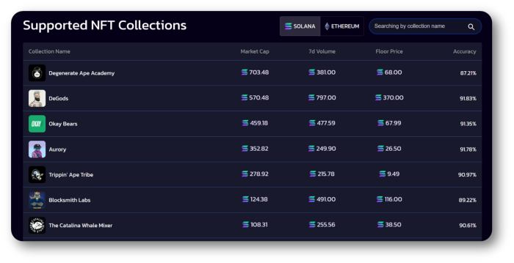

Feeds graph of the Floor Price and AI Floor Price:

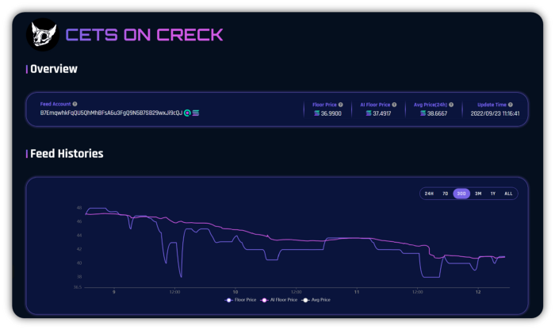

AI Valuation Accuracy: The overall accuracy of AI Valuation has been improved to more than 85%. The accuracy statistics will be released soon.

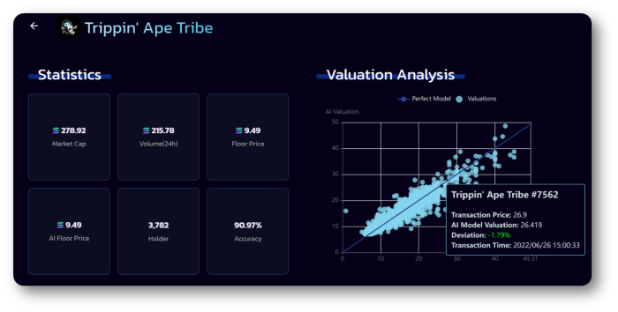

**ETH NFT Valuation:**We have crawled the on-chain data of 100 ETH NFT collections and worked on the data analysis. We will soon release the API for ETH NFTs.

SOL NFT Weekly Analysis: We have updated Weekly NFT Analysis for SOL NFTs. The Analysis has included price tracking, top 5 transaction volumes, top 5 transaction amounts, top 5 listing, and top 5 NFT Collections of new holders in the last week. (refer to [updates](https://twitter.com/banksea_finance/status/1595622349017354240))

# Partnership with Router Protocol

Glad to partner with @routerprotocol which is cross-chain infra enabling communication between blockchains. Stay tuned for further cooperation!

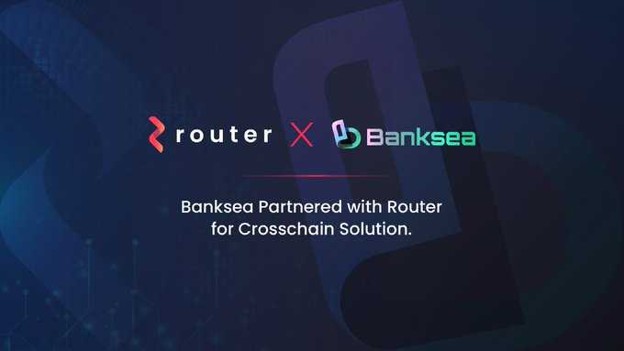

<https://twitter.com/banksea_finance/status/1590010722456842243?s=20&t=WJVaVHKawCx66oDgIrKb1g>

# Partnership with Catheon Gaming



https://twitter.com/banksea_finance/status/1597549697580683264?s=20&t=WJVaVHKawCx66oDgIrKb1g

**Launched Banksea Dashboard for SOL NFTs**

We are glad to launch the Banksea Dashboard for SOL NFTs. Weekly NFT analysis will be shared.

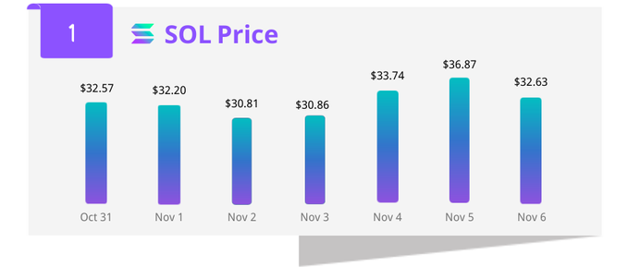

https://twitter.com/banksea_finance/status/1590993665442611202?s=20&t=WJVaVHKawCx66oDgIrKb1g

# The Wrap-up

It’s been busy months and full of news. We have been working on the Oracle launch, AI valuation accuracy, ETH NFTs valuation, NFTs Analysis, and partnership expansion. The team is working hard for the project’s success and is always happy to hear your opinion and feedback.

We look forward to hearing more from you!

**Join and subscribe for more exciting updates !!! ✅**

**👏**[**Website**](https://banksea.finance/)**|**[**Twitter**](https://twitter.com/banksea_finance)**|**[**Discord**](http://discord.gg/F4AcB4ycCQ)**|**[**Telegram**](http://t.me/banksea_finance)**|**[**Medium**](https://medium.com/@BankseaFinance)**👏**

a